

**MATHEMATICS**

**Specialist Units 3 & 4**

**Test 4 – Integration**

**Chapters 13, 14 and 15**

**Semester 2 2017**

# 

**Section Two – Calculator Assumed**

Time allowed for this section

Working time for this section: 20 minutes

Marks available: 20 marks

## Material required/recommended for this section

##### To be provided by the supervisor

This Question/Answer booklet

Formula sheet

##### To be provided by the candidate

Standard items: pens, pencils, pencil sharpener, eraser, correction fluid, ruler, highlighters

Special items: drawing instruments, templates, notes on one unfolded sheet of A4 paper, and up to three calculators satisfying the conditions set by the Curriculum Council for this course.

## Important note to candidates

No other items may be used in this section of the examination. It is **your** responsibility to ensure that you do not have any unauthorised notes or other items of a non-personal nature in the examination room. If you have any unauthorised material with you, hand it to the supervisor **before** reading any further.

1. (4 marks)  
   The area enclosed by the x-axis, the lines $x=1$ and $x=4$ and the curve $y=1+\sqrt{x}$ is rotated $360°$ about the x-axis. Calculate the volume of the solid generated to an accuracy of two decimal places.
2. (6 marks)
3. Find $\int{\frac{5x^{2}-10x-3}{(x+1){(x-1)}^{2}}}$ $dx$ using partial fractions. [3]
4. Hence express $\int_{2}^{5}{\frac{5x^{2}-10x-3}{(x+1){(x-1)}^{2}}}$ $dx$ as a single logarithm. [3]

|  |  |
| --- | --- |
| *x* | *f(x)* |
| 3.0 | 2.87 |
| 3.2 | 2.90 |
| 3.4 | 2.94 |
| 3.6 | 2.97 |
| 3.8 | 3.00 |
| 4.0 | 3.04 |
| 4.2 | 3.08 |
| 4.4 | 3.12 |
| 4.6 | 3.16 |
| 4.8 | 3.20 |
| 5.0 | 3.25 |
| 5.2 | 3.30 |
| 5.4 | 3.36 |
| 5.6 | 3.42 |
| 5.8 | 3.49 |
| 6.0 | 3.56 |
| 6.2 | 3.64 |
| 6.4 | 3.73 |
| 6.6 | 3.82 |
| 6.8 | 3.92 |
| 7.0 | 4.03 |

1. (10 marks)  
   Consider the region enclosed by the curve $y=f\left(x\right), x=3, x=7$ and the $x$ axis.

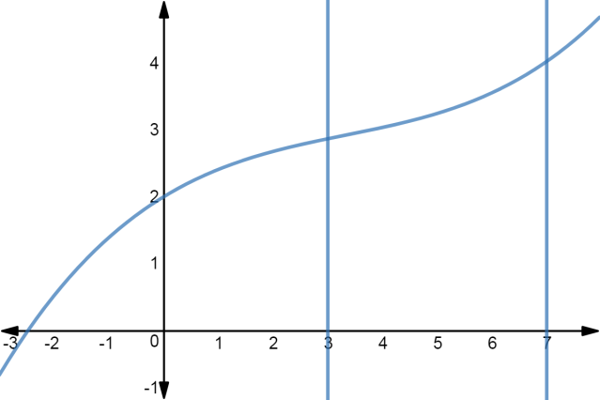  
   
 y

x

The accompanying table shows the value of the function $f(x)$ for

various values of $x, 3≤x≤7.$

The value of the area of this region is $\int_{3}^{7}{f\left(x\right)dx}$ which may be approximated using the Trapezoidal rule:

$$\int_{a}^{b}{f\left(x\right)dx≈\frac{1}{2}}w(y_{0}+2y_{1}+2y_{2}+…+2y_{n-1}+y_{n})$$

or using Simpson’s rule:

$\int_{a}^{b}{f\left(x\right)dx≈\frac{1}{3}}w(y_{0}+4y_{1}+2y_{2}+4y_{3}+2y_{4}…+2y_{n-2}+4y_{n-1}+y_{n})$

where, in each case, $y_{0}=f\left(x_{0}\right)=f\left(a\right), y_{n}=f\left(x_{n}\right)=f(b)$ and $w=$ $\frac{b-a}{n}$

1. Use Simpson’s rule over 4 intervals to approximate $\int_{3}^{7}{f\left(x\right)dx}$ [3]
2. Use the Trapezoidal rule over 5 intervals to approximate $\int_{3}^{7}{f\left(x\right)dx}$ [3]
3. For $y=f(x)$ the following sums were determined

$\sum_{i=1}^{9}{y_{2i}}$ $=29.73$ and $\sum_{i=1}^{10}{y_{2i-1}}$ $=33.16$

Use these sums and Simpson’s rule over 20 intervals to estimate the area of the region. [4]

**End of Section Two**

**This page has intentionally been left blank**

You may use this space to extend or re-attempt an answer to a question or questions and should you do so then number the question(s) attempted and cross out any previous unwanted working.